Wavelabs’ Lab setup consists of n nodes numbered from 0 to n - 1 connected by undirected node-to-node connections forming a network where connections[i] = [ai, bi] represents a connection between nodes ai and bi. Any node can reach other nodes directly or indirectly through the network.

A *critical connection* is a connection that, if removed, will make some nodes unable to reach some other node.

As a network engineer, it's important to maintain a list of critical connections. Return all critical connections in the network in any order.

**Example:**

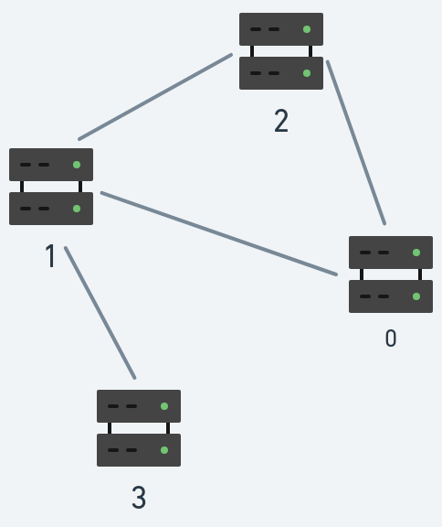

**Input:** n = 4, connections = [[0,1],[1,2],[2,0],[1,3]]

**Output:** [[1,3]]

**Explanation:** [[3,1]] is also accepted.

**Constraints:**

* 2 <= n <= 105
* n - 1 <= connections.length <= 105
* 0 <= ai, bi <= n - 1
* ai != bi
* There are no repeated connections.

**Solve the questions in C/C++/ Go lang only No other Language**